BIOL 812 Final Project

2025-04-04

# Setup

library(ggplot2) # plotting library  
library(dplyr) # data management

##   
## Attaching package: 'dplyr'

## The following objects are masked from 'package:stats':  
##   
## filter, lag

## The following objects are masked from 'package:base':  
##   
## intersect, setdiff, setequal, union

library(lme4) # linear mixed-effects models using Eigen and S4

## Warning: package 'lme4' was built under R version 4.1.2

## Loading required package: Matrix

library(lmtest) # Lagrange multiplier test

## Warning: package 'lmtest' was built under R version 4.1.2

## Loading required package: zoo

## Warning: package 'zoo' was built under R version 4.1.2

##   
## Attaching package: 'zoo'

## The following objects are masked from 'package:base':  
##   
## as.Date, as.Date.numeric

library(stringr)   
library(tidyr)

## Warning: package 'tidyr' was built under R version 4.1.2

##   
## Attaching package: 'tidyr'

## The following objects are masked from 'package:Matrix':  
##   
## expand, pack, unpack

library(RColorBrewer) # colour graphics

## Warning: package 'RColorBrewer' was built under R version 4.1.2

library(sjPlot) # data visualization  
source("http://bit.ly/theme_pub") # set custom plotting theme  
theme_set(theme_pub())

# Download Data

GarDat = read.csv("CommonGarden_Data_With_ENV (2).csv")

# Set random effect (Block) as factor

GarDat <- GarDat %>%   
 mutate(Block=as.factor(Block))

# Linear mixed effects models with fixed environmental effects (Module 3)

GrowthMod1 <- lmer(Height_Growth_Rate ~ Latitude + Precipitation_of_Wettest_Month + Mean_Annual_Temp + Temperature_Seasolity + (1 | Block), na.action = na.exclude, data = GarDat)  
GrowthMod2 <- lmer(Height_Growth_Rate ~ Precipitation_of_Wettest_Month + Mean_Annual_Temp + Temperature_Seasolity + (1 | Block), na.action = na.exclude, data = GarDat)  
GrowthMod3 <-lmer(Height_Growth_Rate ~ Latitude + Mean_Annual_Temp + Temperature_Seasolity + (1 | Block), na.action = na.exclude, data = GarDat)  
GrowthMod4 <- lmer(Height_Growth_Rate ~ Latitude + Precipitation_of_Wettest_Month + Temperature_Seasolity + (1 | Block), na.action = na.exclude, data = GarDat)  
GrowthMod5 <- lmer(Height_Growth_Rate ~ Latitude + Precipitation_of_Wettest_Month + Mean_Annual_Temp + (1 | Block), na.action = na.exclude, data = GarDat)  
GrowthMod6 <- lmer(Height_Growth_Rate ~ Mean_Annual_Temp + Temperature_Seasolity + (1 | Block), na.action = na.exclude, data = GarDat)  
GrowthMod7 <- lmer(Height_Growth_Rate ~ Latitude + Precipitation_of_Wettest_Month + (1 | Block), na.action = na.exclude, data = GarDat)  
GrowthMod8 <- lmer(Height_Growth_Rate ~ Latitude + Temperature_Seasolity + (1 | Block), na.action = na.exclude, data = GarDat)  
GrowthMod9 <- lmer(Height_Growth_Rate ~ Latitude + (1 | Block), na.action = na.exclude, data = GarDat)  
GrowthMod10 <- lmer(Height_Growth_Rate ~ Precipitation_of_Wettest_Month + (1 | Block), na.action = na.exclude, data = GarDat)  
GrowthMod11 <- lmer(Height_Growth_Rate ~ Mean_Annual_Temp + (1 | Block), na.action = na.exclude, data = GarDat)  
GrowthMod12 <- lmer(Height_Growth_Rate ~ Temperature_Seasolity + (1 | Block), na.action = na.exclude, data = GarDat)  
  
lrtest(GrowthMod1, GrowthMod2, GrowthMod3, GrowthMod4, GrowthMod5, GrowthMod6, GrowthMod7, GrowthMod8, GrowthMod9, GrowthMod10, GrowthMod11, GrowthMod12)

## Likelihood ratio test  
##   
## Model 1: Height_Growth_Rate ~ Latitude + Precipitation_of_Wettest_Month +   
## Mean_Annual_Temp + Temperature_Seasolity + (1 | Block)  
## Model 2: Height_Growth_Rate ~ Precipitation_of_Wettest_Month + Mean_Annual_Temp +   
## Temperature_Seasolity + (1 | Block)  
## Model 3: Height_Growth_Rate ~ Latitude + Mean_Annual_Temp + Temperature_Seasolity +   
## (1 | Block)  
## Model 4: Height_Growth_Rate ~ Latitude + Precipitation_of_Wettest_Month +   
## Temperature_Seasolity + (1 | Block)  
## Model 5: Height_Growth_Rate ~ Latitude + Precipitation_of_Wettest_Month +   
## Mean_Annual_Temp + (1 | Block)  
## Model 6: Height_Growth_Rate ~ Mean_Annual_Temp + Temperature_Seasolity +   
## (1 | Block)  
## Model 7: Height_Growth_Rate ~ Latitude + Precipitation_of_Wettest_Month +   
## (1 | Block)  
## Model 8: Height_Growth_Rate ~ Latitude + Temperature_Seasolity + (1 |   
## Block)  
## Model 9: Height_Growth_Rate ~ Latitude + (1 | Block)  
## Model 10: Height_Growth_Rate ~ Precipitation_of_Wettest_Month + (1 | Block)  
## Model 11: Height_Growth_Rate ~ Mean_Annual_Temp + (1 | Block)  
## Model 12: Height_Growth_Rate ~ Temperature_Seasolity + (1 | Block)  
## #Df LogLik Df Chisq Pr(>Chisq)   
## 1 7 -699.55   
## 2 6 -703.42 -1 7.7439 0.0053894 **   
## 3 6 -700.61 0 5.6079 < 2.2e-16 ***  
## 4 6 -698.62 0 3.9918 < 2.2e-16 ***  
## 5 6 -694.43 0 8.3752 < 2.2e-16 ***  
## 6 5 -700.99 -1 13.1154 0.0002929 ***  
## 7 5 -693.58 0 14.8088 < 2.2e-16 ***  
## 8 5 -699.63 0 12.0976 < 2.2e-16 ***  
## 9 4 -694.90 -1 9.4671 0.0020919 **   
## 10 4 -699.60 0 9.4071 < 2.2e-16 ***  
## 11 4 -695.93 0 7.3483 < 2.2e-16 ***  
## 12 4 -701.62 0 11.3819 < 2.2e-16 ***  
## ---  
## Signif. codes: 0 '***' 0.001 '**' 0.01 '*' 0.05 '.' 0.1 ' ' 1

# Likelihood ratio test demonstrates statistical significance for all models but GrowthMod1

# AIC and BIC for model selection - GrowthMod7

AIC(GrowthMod1, GrowthMod2, GrowthMod3, GrowthMod4, GrowthMod5, GrowthMod6, GrowthMod7, GrowthMod8, GrowthMod9, GrowthMod10, GrowthMod11, GrowthMod12)

## df AIC  
## GrowthMod1 7 1413.091  
## GrowthMod2 6 1418.835  
## GrowthMod3 6 1413.227  
## GrowthMod4 6 1409.235  
## GrowthMod5 6 1400.860  
## GrowthMod6 5 1411.975  
## GrowthMod7 5 1397.167  
## GrowthMod8 5 1409.264  
## GrowthMod9 4 1397.797  
## GrowthMod10 4 1407.204  
## GrowthMod11 4 1399.856  
## GrowthMod12 4 1411.238

BIC(GrowthMod1, GrowthMod2, GrowthMod3, GrowthMod4, GrowthMod5, GrowthMod6, GrowthMod7, GrowthMod8, GrowthMod9, GrowthMod10, GrowthMod11, GrowthMod12)

## df BIC  
## GrowthMod1 7 1447.035  
## GrowthMod2 6 1447.929  
## GrowthMod3 6 1442.321  
## GrowthMod4 6 1438.330  
## GrowthMod5 6 1429.954  
## GrowthMod6 5 1436.221  
## GrowthMod7 5 1421.412  
## GrowthMod8 5 1433.510  
## GrowthMod9 4 1417.194  
## GrowthMod10 4 1426.601  
## GrowthMod11 4 1419.252  
## GrowthMod12 4 1430.634

# Model selection for height growth rate identifies GrowthMod7 to be best fit

# Plotting Best Model for Height Growth Rate

p <- sjPlot::plot_model(GrowthMod7, title = "Effect of Fixed Effects on Height Growth Rate")  
p+theme_sjplot()

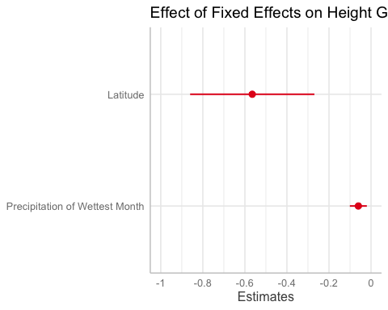

tab_model(GrowthMod7,  
 show.re.var = TRUE, dv.labels = "Effect of Fixed Effects on Height Growth Rate")

Effect of Fixed Effects on Height Growth Rate

Predictors

Estimates

CI

p

(Intercept)

33.54

15.57 – 51.50

<0.001

Latitude

-0.56

-0.86 – -0.27

<0.001

Precipitation of WettestMonth

-0.06

-0.10 – -0.02

0.003

Random Effects

σ2

0.25

τ00 Block

0.03

ICC

0.12

N Block

4

Observations

943

Marginal R2 / Conditional R2

0.025 / 0.140

# Plot presents a negative relationship between latitude and Height Growth rate (Figure of best model as per AIC)

# Plotting Model with all variables (model not significant or the best as per AIC)

p2 <- sjPlot::plot_model(GrowthMod1, title = "Effect of Fixed Effects on Height Growth Rate")  
p2+theme_sjplot()

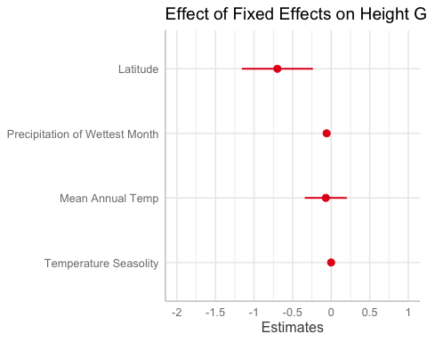

tab_model(GrowthMod1,  
 show.re.var = TRUE, dv.labels = "Effect of Fixed Effects on Height Growth Rate")

Effect of Fixed Effects on Height Growth Rate

Predictors

Estimates

CI

p

(Intercept)

41.34

15.75 – 66.93

0.002

Latitude

-0.70

-1.16 – -0.24

0.003

Precipitation of WettestMonth

-0.06

-0.10 – -0.02

0.005

Mean Annual Temp

-0.07

-0.34 – 0.20

0.617

Temperature Seasolity

-0.00

-0.01 – 0.00

0.517

Random Effects

σ2

0.25

τ00 Block

0.03

ICC

0.12

N Block

4

Observations

943

Marginal R2 / Conditional R2

0.026 / 0.142

# Plot of all variables demonstrating a negative relationship between fixed variables and Height Growth rate

# ANOVA on most significant variables from LMM Height Growth Rate (Module 2)

summary(GrowthMod7)

## Linear mixed model fit by REML ['lmerMod']  
## Formula: Height_Growth_Rate ~ Latitude + Precipitation_of_Wettest_Month +   
## (1 | Block)  
## Data: GarDat  
##   
## REML criterion at convergence: 1387.2  
##   
## Scaled residuals:   
## Min 1Q Median 3Q Max   
## -3.2451 -0.8196 0.0003 0.6785 2.9653   
##   
## Random effects:  
## Groups Name Variance Std.Dev.  
## Block (Intercept) 0.0331 0.1819   
## Residual 0.2483 0.4983   
## Number of obs: 943, groups: Block, 4  
##   
## Fixed effects:  
## Estimate Std. Error t value  
## (Intercept) 33.53687 9.15571 3.663  
## Latitude -0.56488 0.15056 -3.752  
## Precipitation_of_Wettest_Month -0.06037 0.02060 -2.931  
##   
## Correlation of Fixed Effects:  
## (Intr) Latitd  
## Latitude -0.999   
## Prcptt__W_M -0.988 0.980

anova(GrowthMod7)

## Analysis of Variance Table  
## npar Sum Sq Mean Sq F value  
## Latitude 1 4.7699 4.7699 19.2135  
## Precipitation_of_Wettest_Month 1 2.1320 2.1320 8.5879

# Evaluating how most significant LMM variables affect Germination using ttests (Module 1)

t.test(GarDat$Latitude~GarDat$Germited)

##   
## Welch Two Sample t-test  
##   
## data: GarDat$Latitude by GarDat$Germited  
## t = -6.8887, df = 564.05, p-value = 1.508e-11  
## alternative hypothesis: true difference in means between group 0 and group 1 is not equal to 0  
## 95 percent confidence interval:  
## -0.2704539 -0.1504439  
## sample estimates:  
## mean in group 0 mean in group 1   
## 46.49397 46.70442

t.test(GarDat$Precipitation_of_Wettest_Month~GarDat$Germited)

##   
## Welch Two Sample t-test  
##   
## data: GarDat$Precipitation_of_Wettest_Month by GarDat$Germited  
## t = 6.3469, df = 597.52, p-value = 4.347e-10  
## alternative hypothesis: true difference in means between group 0 and group 1 is not equal to 0  
## 95 percent confidence interval:  
## 0.9270451 1.7578450  
## sample estimates:  
## mean in group 0 mean in group 1   
## 106.0192 104.6768

# Two sample t-tests demonstrate statistical significance between both variables and Germination

# Plotting germination data

ggplot(GarDat, aes(x=as.factor(GarDat$Germited), y=GarDat$Latitude, color=as.factor(GarDat$Germited))) +  
 geom_boxplot(alpha=0.3) + labs(title="Germination with respect to latitude", x="Germination", y="Latitude")

## Warning: Use of `GarDat$Germited` is discouraged. Use `Germited` instead.

## Warning: Use of `GarDat$Latitude` is discouraged. Use `Latitude` instead.

## Warning: Use of `GarDat$Germited` is discouraged. Use `Germited` instead.

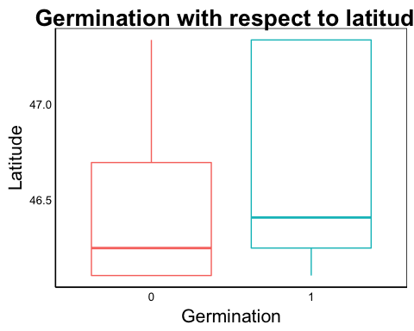

ggplot(GarDat, aes(x=as.factor(GarDat$Germited), y=GarDat$Precipitation_of_Wettest_Month, color=as.factor(GarDat$Germited))) +  
 geom_boxplot(alpha=0.3) + labs(title="Germination with respect to precipitation", x="Germination", y="Precipitation of Wettest Month")

## Warning: Use of `GarDat$Germited` is discouraged. Use `Germited` instead.

## Warning: Use of `GarDat$Precipitation_of_Wettest_Month` is discouraged. Use  
## `Precipitation_of_Wettest_Month` instead.

## Warning: Use of `GarDat$Germited` is discouraged. Use `Germited` instead.

